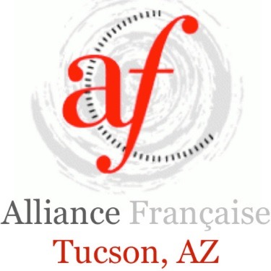

**Minutes for AFT Annual Meeting**

**December 8, 2015 at 6pm**

In attendance from the AFT Staff & 2015 Board:

Magali Bergolla

Mary Carryer

Rosann Gonzalez

Dianne Janis

Rebecca McSwain

Elyse Petit-Genet

Nina Pitzer

Additional attendees included 24 AFT members.

Elyse Petit-Genet, outgoing AFT Board President, called the meeting to order at 6:02 pm and welcomed attendees.

Introductions were made of the current board members.

Rosann moved to approve the Minutes with Elyse seconding the motion. Minutes were approved with no dissenting votes.

Mary led a discussion about the AFT bylaws. She detailed the process that had taken place to review them and explained the mandates necessary to accommodate in order to satisfy the ruling Federation. The bylaws had been on the AFT website for the public at large to examine/review. All AFT members also received an electronic copy of the bylaws along with their voting ballots. Members could vote to accept “all” amendments or they could vote item by item.

A brief discussion addressed the nomenclature regarding “Board of Directors.” It was suggested that AFT confer with the Phoenix chapter to compare bylaw changes.

Introductions were made of the candidates for AFT Board 2016:

Octavio Armendariz

Mary Carryer

Christine Deymier

Rosann Gonzalez

Dianne Janis

Steve Jeton

Rebecca McSwain

Raymonde Zlotnikoff

Elyse thanked the 2015 Board Members for their contributions and support.

The ballots were collected and tallied. A quorum was reached with 40% participation. A total of 57 votes were received from the 121-member base. 51 votes approved the bylaw changes in their entirety.

**Financials**

Rosann presented a detailed report on the November 2015 AFT Financials, copy attached. She highlighted the recent success of the AFT’s Challenge Grant campaign that raised $3080.

**Executive Director’s Report**

Magali addressed the group to present the vision for the future of AFT. In addition to classes, AFT is now scheduling regular Grammar Workshops that are very well attended. The workshops have provided a new revenue stream for the organization.

*Tucson Meet Yourself* had been a good source of income for AFT but net results from that event has dwindled from $2,500 in 2013 to $1,800 in 2014, and finally to $1,294 in 2015. An enormous amount of work goes into participating in this event – not only the staggering amount of hours that the booth must be staffed but also the immense amount of effort that goes on prior to the event with many people cooking the food items.

To create more of a community feeling, the AFT will launch a monthly potluck for members to socialize with each other.

Winter 2015 had 5 classes comprised of 46 students; Fall had 26 students. On average the AFT had 166 students during the whole year. There were 25 classes in total.

The monthly film will continue as well as the Book Club.

A carnival in February (Mardi Gras) is being considered.

It is AFT’s desire to establish (“brand”) itself as the center of the Tucson Francophone community.

The 2016 Board members were announced:

Mary Carryer Member at Large

Christine Deymier Member at Large

Rosann Gonzalez Treasurer

Dianne Janis Secretary

Steve Jeton Member at Large

Rebecca McSwain President

Raymonde Zlotnikoff Vice President

Rosann moved to adjourn the meeting with Rebecca seconding the motion.

*Minutes prepared and submitted by Dianne Janis, AFT Secretary.*

# # #